My path to the Scale side of Life

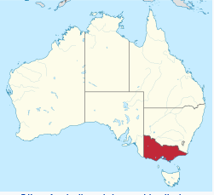 Victoria (red) Australia
Hi, my name is Mal Campbell, I live in Melbourne, Victoria, Australia and I am new to the ISASC and to scale and weight collecting.

My scale and weight journey started a few years ago, while on a day out, gold detecting, in central Victoria Australia, I found a curious little object, a half pennyweight. Location, Amherst, Victoria, which is coincidentally in the geographic centre of Victoria. No one found gold that day, but I found a little treasure which was to open a new interest in my life. It was not just any half pennyweight but a W & T A half pennyweight.
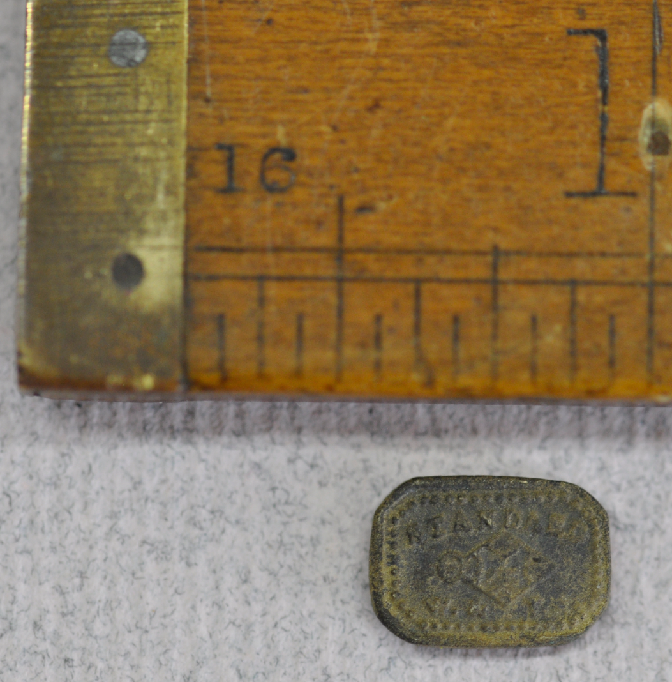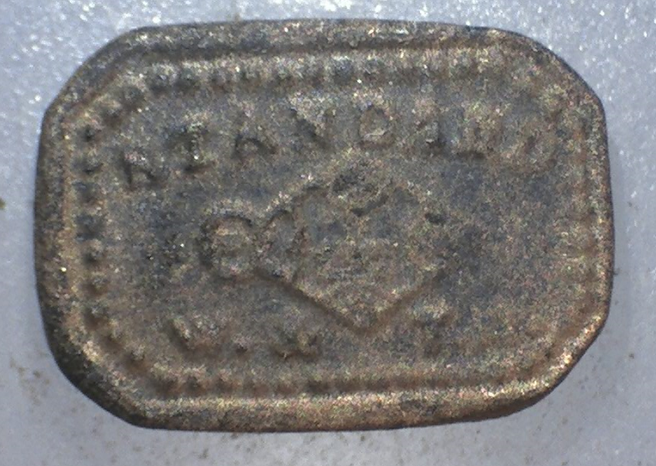
Actual (left) and magnified X10 (right).

That pennyweight sat with some of my other interesting but miscellaneous finds (musket balls, coins, part of a wick trimmer, buttons, etc) for a couple of years. Then one day in early 2016, I was cleaning it up a bit and started to wonder who were W & T A? I soon discovered who W & T Avery were.
Victoria was one of the largest gold producing areas in the world and more large gold nuggets have been found in Victoria that elsewhere in the world. The Welcome Stranger 2,315 troy oz was found in 1869, a bit further north in Dunolly, Victoria. The largest nugget found with a detector was found further north in 1989, 874 troy oz. You can Google Victoria, Australia, Golden Triangle and look at the images of finds, - takes your breath away. My finds from 1 troy ounce and much smaller pale into insignificance; but are priceless to me as I am the first person to find them in over 400 million years. I love the activity of getting out into the outdoors with mates (Australian slang for friends) and in turn it has heightened my interest in our history, geology, flora, fauna, the general preservation of and re-establishment of biodiversity of our native bushland, and now scales and weights.
Once I started to research W & T Avery, I realised that eBay was a good source of interesting scales and weights, locally, in the USA and UK. My interest in gold and the goldfields furthered my interest in penny weights; other troy weights and in the scales used in the goldfields.
The small portable scales would have been used to measure the gold that prospectors sold to buyers or exchanged for supplies with shop keepers who set up shop in tents throughout the goldfields. When a rush petered out and the miners moved on to another area and the shopkeepers followed them. When alluvial gold became scarce and hard rock deep mines were introduced to follow the seams of gold down through the quartz, others dug deep to find ancient river beds or deep leads which also contained gold. Large steam driven pumps were required to lower the water table to allow mining and railways were built to open up the country side. The discovery of gold was the start of many industrial companies throughout Victoria, sadly not many are still around.

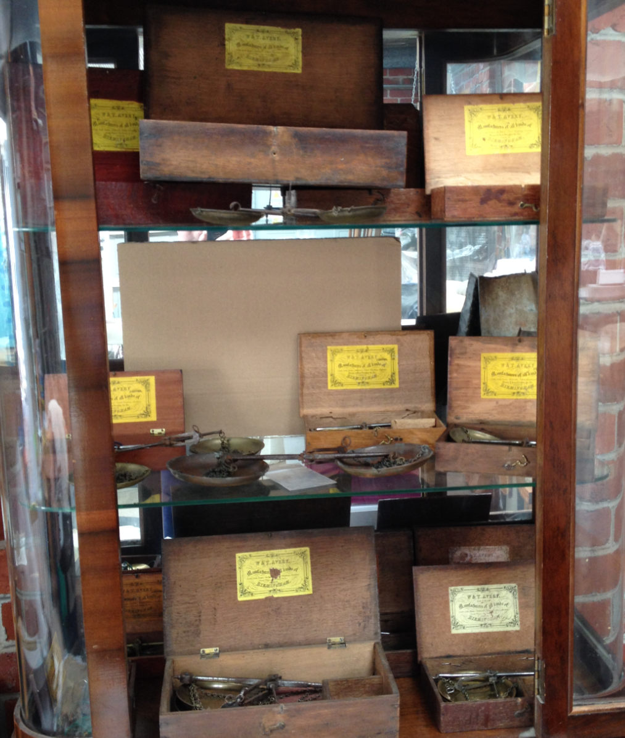
A snapshot of most of my small but growing collection of W&TA portable scales (for better quality images of the labels and pan stamps refer http://collectinggoldscalestroyweights.co.nz/ )

On eBay, I spied sets of small beam scales in boxes with labels inside the lid and a few weights in a small corner division in the boxes. Before long I realised that they were not all the same, another challenge to be dealt with and solved. Along the way I realised that these small scales were not a large part of the huge Avery business and certainly not at the high end of the products they made. Therefore, it has not been easy to find out a lot of information, which is no doubt part of the attraction. This led me to search for catalogues for more detail of the scales. I am now also collecting old Avery catalogues as they assist in dating scales of various sorts. I have some from the late 1890s onwards but I am looking back further, before 1890. I would be keen to hear from anyone who is prepared to sell catalogues of share copies. I have already swapped a few with Ritzo in Netherlands, thanks Ritzo. It is also great to be able to treasure and preserve these old books, which are a wonderful record of their times together with the trades and industries which used the scales and weighing machines.

So, along the way I have collected nearly 20 sets of small beam scales in boxes with varying labels. Of the 6 labels that I know to exist, I have all except one. The missing label was the first one I saw on eBay and at the time it looked like a photocopy but I later realised it was different from all others I have seen, and I am still searching for one of these. Coincidently, I found out recently that a fellow ISASC member and my good friend Tony McCarthy in New Zealand had purchased that set of scales and weights in early 2016. Small world, isn’t it. I am so pleased it is in safe and appreciative hands. I have been very fortunate to meet Tony via ISASC. More about Tony below.
The W&TA scale pans also have differing markings stamped on them. There is more mystery to be solved here. There are references to the Late T Beach (first half of 19th century), and W&TA trademark which has a crown stamped at the top.There are some which do not have the crown. Why? Which one came first? What is the time frame for each stamp? Another stamp refers to “By His Majesty’s Royal Letters Patent”, which has no W&TA reference on it but I believe it is W&TA as the only examples I have seen come with a box with W&TA label inside the lid. So many more mysteries to solve.
I also have a couple of non W&TA small beam scales in boxes, as well as 3 W&TA steelyards scales, 1 W&TA Counter Scales (circa 1916) and a very small set of scales in a tin which were found by the seller in the Victorian goldfields. He kindly included an old penny and a Chinese coin in with the scales, which were found near the scales.
It is amazing how far and wide these scales and weights have travelled. W&TA scales and weights manufactured in the UK have ended up in Australia. One set of scales I purchased from USA had accompanying round stacked troy oz weights, one of which had a verification stamp from Victoria Australia. I have not come across very much written about the systems of verification in the various states of Australia.
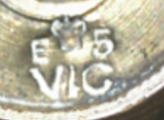 E 5 under crown with VIC further below. The “5” indicates Eaglehawk Borough. Eaglehawk today is a suburb of Bendigo, a city built on gold
As time in my working life permits I am following up at the Public Records Office of Victoria in an effort to gather information about the numbers used for various shires, district unions and boroughs. The Borough of Amherst, where I found my first half pennyweight was number 22. New South Wales also had a verification system, but that will be another search in the future. If any members have any information or sources for details of verification systems implemented in the various states of Australia, I would like to hear from you.
Along my short journey in the world of scales and weight collecting, I have been overwhelmed by the welcoming and generosity of spirit which has been afforded me by members of ISASC USA and Europe. I regard myself to have been fortunate to have joined this group. My queries have been answered generously and my connection with Tony, my New Zealand colleague is developing. Tony and I have set up a small web site, focussed on early gold mining in NZ, troy weights and a section about W&TA boxes and scales. http://collectinggoldscalestroyweights.co.nz/ Tony has a fabulous collection of large troy weights and other associated scales. Tony’s Grandad was involved in gold mining in New Zealand and in particular dredging for gold. Tony has an article in EQM Issue 1 2017, a great read. There were a number of dredges in Victoria, but other than the remains of a couple of them little visible evidence remains.
My other interests are a small bush property in country Victoria where we spend some weekends. I have a number of nest boxes fixed to our native Eucalypt trees to support and encourage small marsupials, brush tailed phascogales (suggest you Google them) and sugar gliders. The trees on our property and in the local area, having been felled a number of times since the mid 1800s gold mining activities. Although there are many large trees, not many are old enough to have natural hollows for the nesting sites required by these marsupials. The brush tailed phascogales are currently threatened and are rarely seen as they are nocturnal, live only a year and are worthy of assistance.
I also plant a few native trees each year raised from seed collected on the property. Only a few per year as the ground is very rocky and hard, and I limit the holes I have to dig. Interestingly, the trees that seed naturally, grow quicker than those that I plant.
My other interest is in our Australian Rule Football completion, a game unlike most others. Too hard to explain here, Google or YouTube it. It is played from March until late September and I miss it when it is out of season.
Thanks to all members of the ISASC for the warm weIcome. I would welcome any questions or comments as well as any information regarding the chronology of the box labels and the scale pan stamps and sources for old catalogues. camwens@bigpond.net.au.

